Department of Computer Engineering

Practical - 11

Practical Title: Student Management CRUD with Search and Filter

Problem Definition: Create a student management module to add, view, edit, delete, search and filter student records. All database operations must use MySQLi prepared statements and display clear success/failure messages.

Theory :
- Are SELECT, INSERT, UPDATE, and DELETE operations working?
Yes. All CRUD operations use parameterized MySQLi statements. Records can be dynamically created (with uniqueness checks), retrieved (with dynamic filters), modified (pre-populated), and soft-deleted or restored.

Is search by name/email/course implemented?
Yes. Fuzzy search matches across full names, emails, and enrollment numbers using SQL LIKE ? bindings, with dropdown filters for course and active/deleted status.

Are delete operations confirmed before execution?
Yes. Deletion triggers a JavaScript confirm() dialog to prevent accidental record removal.

How are Intermediate and Advanced extensions implemented?
Intermediate: export_csv.php streams student data to the client using PHP fputcsv(). Advanced: Soft deletion updates status to deleted, preserving referential integrity with a restore option.

Implementation / Output / Result
// Parameterized Multi-Field Search Query
$query = "SELECT * FROM students WHERE status = ? AND (full_name LIKE ? OR email LIKE ? OR enrollment_no LIKE ?)";
$stmt = $conn->prepare($query);
$stmt->bind_param("ssss", $status, $search_term, $search_term, $search_term);
$stmt->execute();
$result = $stmt->get_result();

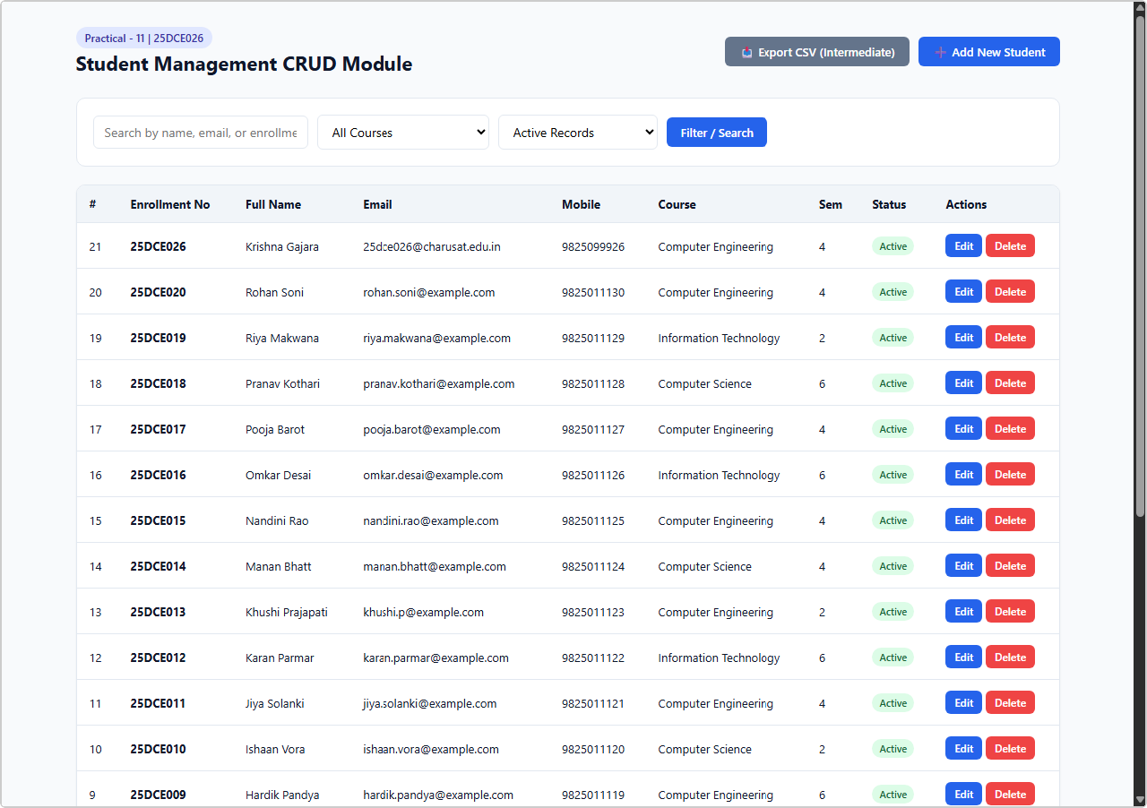
Output 1: Student Management Table with 21 Seeded Records, Multi-Field Search & Filter
Live browser screenshot: Full data table with Enrollment No, Name, Email, Course, Semester, Status columns and Edit/Delete actions.

Output 2: Add New Student Form with Validation
Live browser screenshot: Add Student form with all required fields — enrollment number, full name, email, course, semester, gender.

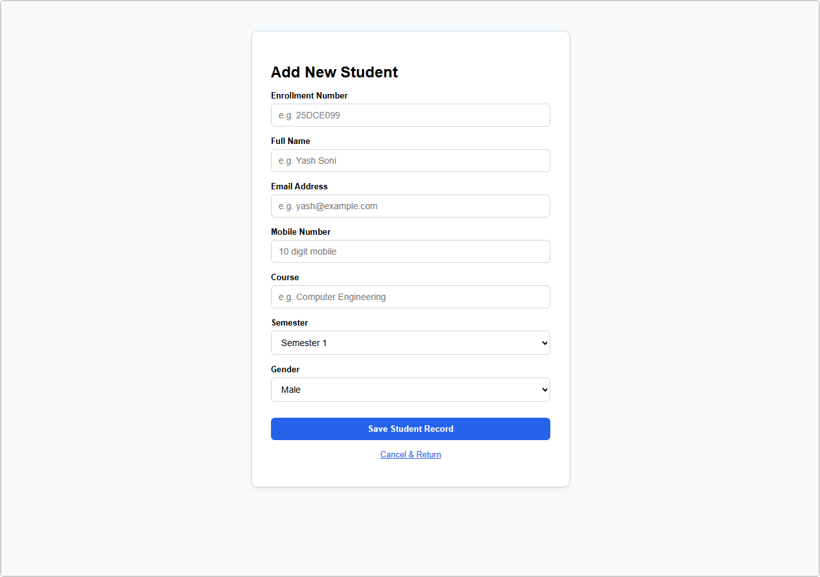

GitHub Repository Link:
https://github.com/bhavya13032007/studenthub/tree/main

Learning Outcomes:
- Constructed a complete data-driven Student CRUD management system in PHP and MySQL.
- Implemented secure parameterized prepared statements across all database queries.
- Created multi-parameter search algorithms supporting name, email, and course filtering.
- Guarded against accidental data loss via client-side JavaScript confirmation dialogs.
- Designed a soft-delete architecture preserving historical and relational integrity.
- Built an automated CSV export utility using PHP stream handlers.
- Managed and validated operations against a dataset of 21 seeded records.

